# **Website Designing (Module – 7 JQuery Basic, Effects & Advanced)**

**(Q.1)** **What is jQuery?**

**(ANS):**

jQuery is a fast, small, and feature-rich JavaScript library. It simplifies tasks such as HTML document traversal and manipulation, event handling, animation, and AJAX (asynchronous JavaScript and XML) interactions for web development. jQuery is designed to make the client-side scripting of HTML easier, providing a concise and easy-to-use API (Application Programming Interface) that works across different browsers.

**Key features of jQuery include:**

1. ***DOM Manipulation:*** jQuery simplifies the process of selecting and manipulating HTML elements in the Document Object Model (DOM). It provides a convenient syntax for tasks such as element selection, modification, and traversal.
2. ***Event Handling:*** jQuery makes it easy to handle events such as clicks, keypresses, and mouse movements. Event handling is simplified with methods like on() and click().
3. ***AJAX:*** jQuery simplifies the implementation of AJAX, allowing developers to make asynchronous requests to the server and update parts of a web page without requiring a full page reload. The $.ajax() function is commonly used for this purpose.
4. ***Animations:*** jQuery provides methods for creating smooth animations on web pages. This includes effects like fading in/out, sliding up/down, and custom animations.
5. ***Cross-Browser Compatibility:*** One of the main goals of jQuery is to provide a consistent API that works across different web browsers, helping developers avoid the complexities of handling browser-specific quirks and inconsistencies.

To use jQuery in a web page, you typically include the jQuery library by adding a <script> tag that references the jQuery file. Once included, you can then use jQuery methods to enhance the interactivity and functionality of your web pages.

It's worth noting that while jQuery was once widely used, modern web development practices have shifted towards using more native JavaScript features and newer libraries and frameworks. As of my last knowledge update in January 2022, jQuery is still used in many projects, but its prominence has diminished with the rise of other technologies. Always check for the latest trends and best practices in web development.

**(Q.2) How to Apply CSS Using JQuery, How to Add Class and Remove Class in**

**Jquery, JQuery Animation?**

**(ANS):**

***Applying CSS Using jQuery:***

You can use jQuery to apply CSS styles to HTML elements. The css() method in jQuery allows you to get or set the CSS properties of an element. Here's a simple example:

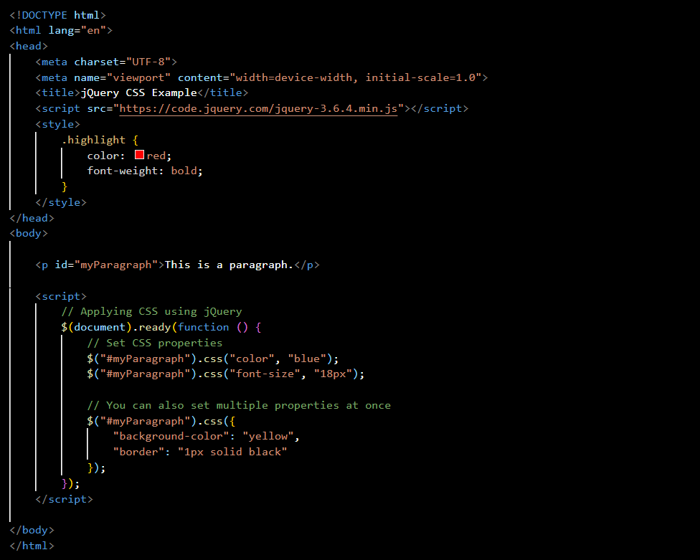

***Adding and Removing Classes in jQuery:***

You can use the addClass() and removeClass() methods to add and remove classes from HTML elements:

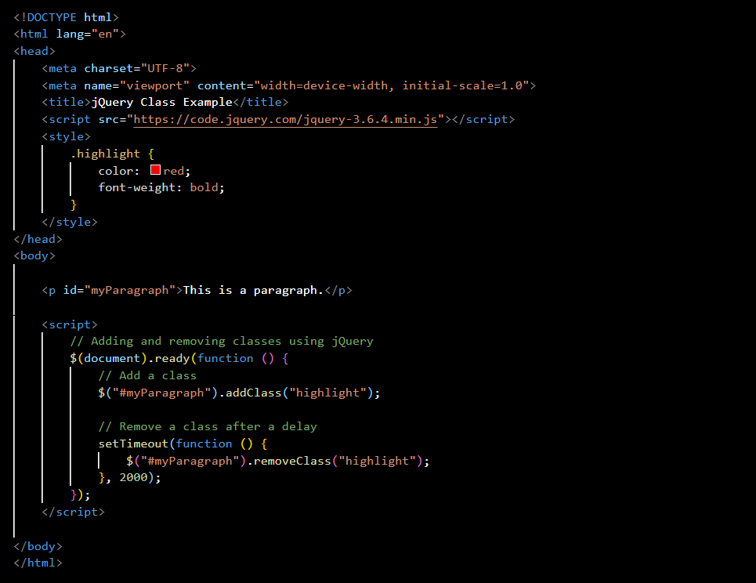

***jQuery Animation:***

jQuery provides several methods for creating animations. One common method is the animate() function, which allows you to animate CSS properties. Here's an example:

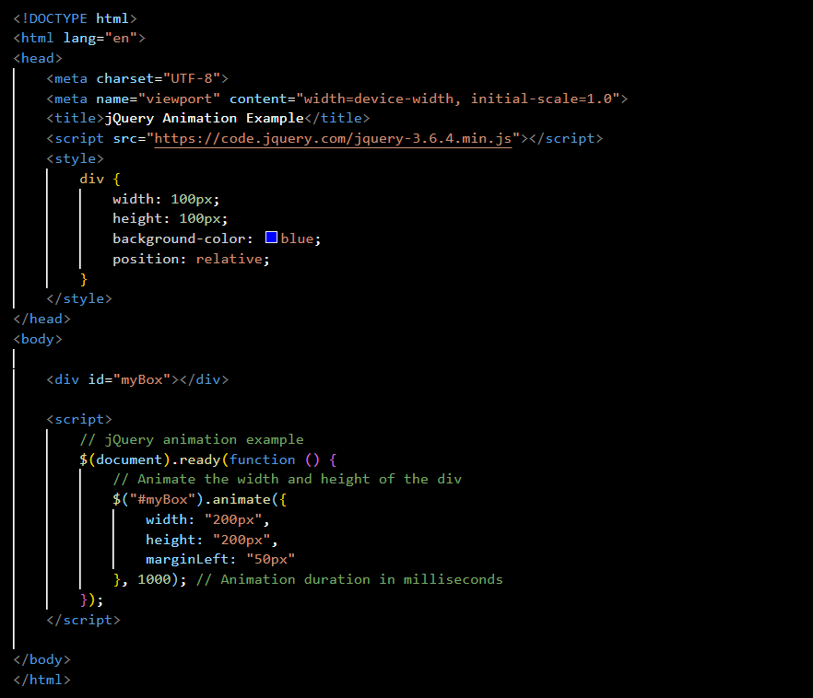

These examples should give you a basic understanding of how to apply CSS, add and remove classes, and perform simple animations using jQuery. Remember to include the jQuery library in your HTML file to use these features.

**(Q.3) How to create slider with animation?**

**(ANS):**

Creating a slider with animation involves using HTML, CSS, and JavaScript (or jQuery). Here's a simple example using HTML, CSS, and jQuery for a basic image slider:

***HTML:***

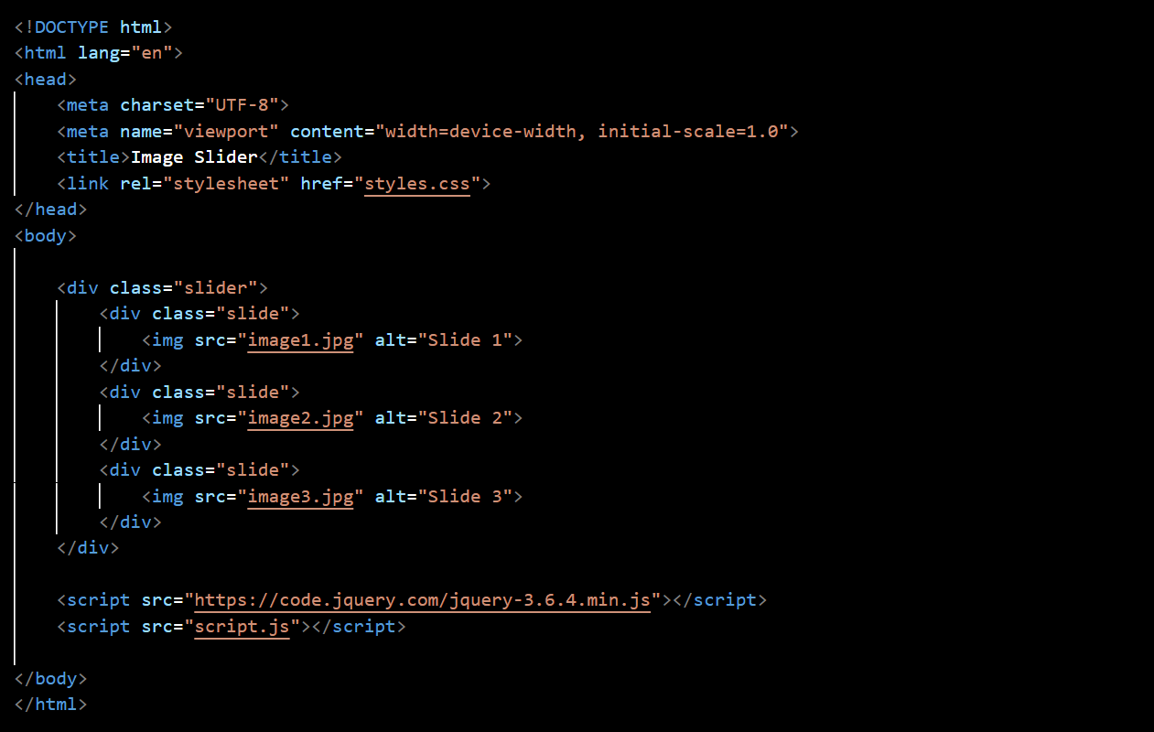

***CSS (styles.css):***

***JavaScript/jQuery (script.js):***

This example sets up a basic image slider with left and right navigation buttons. The images transition with a slide effect. You can customize the HTML, CSS, and JavaScript to fit your specific needs, such as adding captions, changing styles, or adjusting the timing of the automatic slide transitions.

**(Q.4) Event bubbling tickling example**

**(ANS):**

Event bubbling refers to the propagation of events through the DOM hierarchy. When an event occurs on a particular element, it can trigger that event on its parent elements as well, propagating up the DOM tree. This is known as event bubbling.

Let's consider a simple HTML example to illustrate event bubbling using a tickling metaphor:

In this example:

* The HTML structure consists of a grandparent <div>, a parent <p> element, and a child <span> element.
* Each element has a distinct background color for visual clarity.
* The JavaScript/jQuery code attaches click event handlers to each element.
* When you click on the "Tickle me!" text, the click event is triggered on the child, then bubbles up to the parent and grandparent.
* Without the event.stopPropagation() in the child's click handler, all three messages ("Child tickled!", "Parent tickled!", and "Grandparent tickled!") would be logged to the console. However, with stopPropagation(), only "Child tickled!" is logged, as it prevents the event from further propagation.

This example helps visualize how event bubbling works in the context of a tickling scenario. It's important to note that while event bubbling is the default behavior in most browsers, you can also use event capturing by setting the third parameter of the addEventListener method to true.